**LEBANESE AMERICAN UNIVERSITY**

**USAID – HIGHER EDUCATION SCHOLARSHIP PROGRAM**

**HES - Volunteering Program Verification Form**

This form is to be used to document volunteering hours. If a student volunteers for multiple organizations, a separate form must be used for each organization. **This form must be turned in by the 28th of each month, the latest.**

I certify that the scholar Ourouba Al Sahmarany completed a total of 5 hours of service at InnovaThrive.

The hours were completed hours as per the below:

Hours # 0 (date) _2/12 – 6/12_ (initials of supervisor) __A.K.___

Hours # 0 (date) _9/12 – 13/12_ (initials of supervisor) __A.K.___

Hours # 5 date) _16/12 – 20/12 (initials of supervisor) __A.K.___

Hours # 0 date) _23/12 - 27/12 (initials of supervisor) __A.K.___

Brief description of the activities the scholar performed or participated in:

I conducted research on the role of social proof in consumer decision-making, examining how social influences such as testimonials, reviews, and influencer marketing impact purchasing behavior. The study highlighted the advantages of social proof, including increased trust, credibility, and the likelihood of consumer engagement. However, it also explored challenges like the potential for misleading or fake reviews and the ethical concerns surrounding influencer marketing.

Written feedback about the scholar’s performance:

Ourouba’s research on social proof in consumer decision-making was insightful. She discussed the benefits of social proof while addressing challenges like misleading reviews and ethical concerns in influencer marketing.

Please rate the overall performance of the scholar at your organization:

|  |  |  |  |
| --- | --- | --- | --- |
|  | Mastery (5) | Proficient (3) | Emerging (1) |
| **Problem solver** | X |  |  |
| **Engaged & Committed** | X |  |  |
| **Open-minded & multicultural** | X |  |  |

Signature

& stamp

__________________________

_

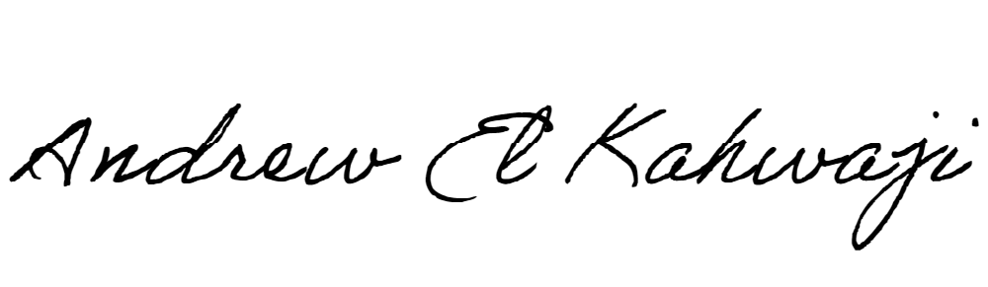

Printed Name _Andrew El Kahwaji_

Date __26/12/2024___

Email __andrew.lifesculptor.coo@gmail.com __

Phone __+961 71 914 378__